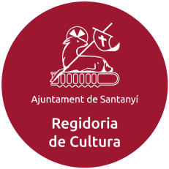
CANAL´ART SANTANYÍ
14TH OCTOBER 2022
From 5 pm to 11 p

- Open call to anyone who has a venue to stage art exhibitions or who would like to set one up for this night: professional art galleries, commercial and private establishments.
- Open call for artists of different disciplines: painting, sculpture, video art, ceramics, photography, crafts and associations dedicated to this.
- Public spaces will be managed directly by the Culture Department. If anyone is interested in displaying their own work in a public space (square, street, pavement, etc.), please make contact via email: santanyicultura@gmail.com
- With the details of all the participants, a map of the art circuit will be drawn up with the start times, artists and places that are taking part. This will serve as a visitor’s guide.
- If you have a logo for advertising use, you can send it to santanyicultura@gmail.com, in jpg or png. format before 2th Setember.
- The person or entity that signs this application undertakes to keep the exhibition space open on 14th October 2022 from 5 pm to 11 pm. If you so wish, you may extend the opening times.
- Registration open until 2th Setember.
- Persons older than 18, associations and businesses may register.

APPLICATION
Mark with an X:
Establishment___ Artist___ Association____

Name and surname(s):
Name of the establishment:
Name of the individual artist or artists who are exhibiting there (add the discipline: painting, sculpture, ceramics, jewellery, video art, etc.):
Street: nr:
Postcode: Town/city:
Contact telephone:
Email:
DNI/NIF/ID doc. no:

I accept the conditions
Signed:
Date:
Notice
In accordance with current legislation, we inform you that the information included in this application is CONFIDENTIAL and for the exclusive use of the Culture Department at Santanyí Council, and will only be used for the Canal'Art 2022 event. That by signing this, you grant permission for your data to be used to organise this event, to appear in the Canal'Art 2022 map-guide and to be included in a list for future annual Canal'Art events.

